UNIVERSITY OF WAH (UOW)

DEPARTMENT OF COMPUTER SCIENCE



BSCS 3RD B

REG #: UW-24-CS-BS-088

SUBMITTED BY: SAADI SAFDAR

SUBMITTED TO: Ms. MUNNIBA KHAN

COURSE TITLE: DATA STRUCTURES

COURSE CODE: CS – 201 L

LAB REPORT # 6

Lab Tasks:

Problem 1 – Linked List Insertion & Display
Task:
1. Write a program to create a Singly Linked List.
2. Implement functions to:
o Insert a node at the beginning
o Insert a node at the end
o Insert a node at a specific position
3. Implement a function display() to traverse and print the linked list.
Test Case:
• Insert 10 at beginning, 20 at end, 15 at position 2.
• Expected Output: 10 -> 15 -> 20 -> NULL

Code:

#include <iostream>
using namespace std;

struct Node {
int data;
Node* next;
};

class LinkedList {
private:
Node* head;
Node* tail;

public:
LinkedList() {
head = NULL;
tail = NULL;
}

Node* createNode(int value) {
Node* temp = new Node;
temp->data = value;
temp->next = NULL;
return temp;
}

void insertBegin(int value) {
Node* temp = createNode(value);
if (head == NULL) {
head = tail = temp;
} else {
temp->next = head;
head = temp;
}
}

void insertLast(int value) {
Node* temp = createNode(value);
if (head == NULL) {
head = tail = temp;
} else {
tail->next = temp;
tail = temp;
}
}

void insertPos(int value, int pos) {
if (pos < 1) {
cout << "Position should be >= 1\n";
return;
}
if (pos == 1) {
insertBegin(value);
return;
}
Node* temp = createNode(value);
Node* current = head;
for (int i = 1; i < pos - 1; i++) {
if (current == NULL) {
cout << "Position out of range\n";
return;
}
current = current->next;
}
if (current == NULL) {
cout << "Position out of range\n";
return;
}
temp->next = current->next;
current->next = temp;
if (temp->next == NULL) {
tail = temp;
}
}

void display() {
if (head == NULL) {
cout << "List is empty\n";
return;
}
Node* current = head;
cout << "Linked List: ";
while (current != NULL) {
cout << current->data << " -> ";
current = current->next;
}
cout << "NULL\n";
}
};

int main() {
LinkedList list;
int choice, value, pos;
do {
cout << "\n--- Linked List Operations ---\n";
cout << "1. Insert at Beginning\n";
cout << "2. Insert at End\n";
cout << "3. Insert at Position\n";
cout << "4. Display List\n";
cout << "5. Exit\n";
cout << "Enter your choice: ";
cin >> choice;
switch (choice) {
case 1:
cout << "Enter value: "; cin >> value;
list.insertBegin(value);
break;
case 2:
cout << "Enter value: "; cin >> value;
list.insertLast(value);
break;
case 3:
cout << "Enter value: "; cin >> value;
cout << "Enter position: "; cin >> pos;
list.insertPos(value, pos);
break;
case 4:
list.display();
break;
case 5:
cout << "Exiting...\n";
break;
default:
cout << "Invalid choice!\n";
}
} while (choice != 5);
return 0;
}

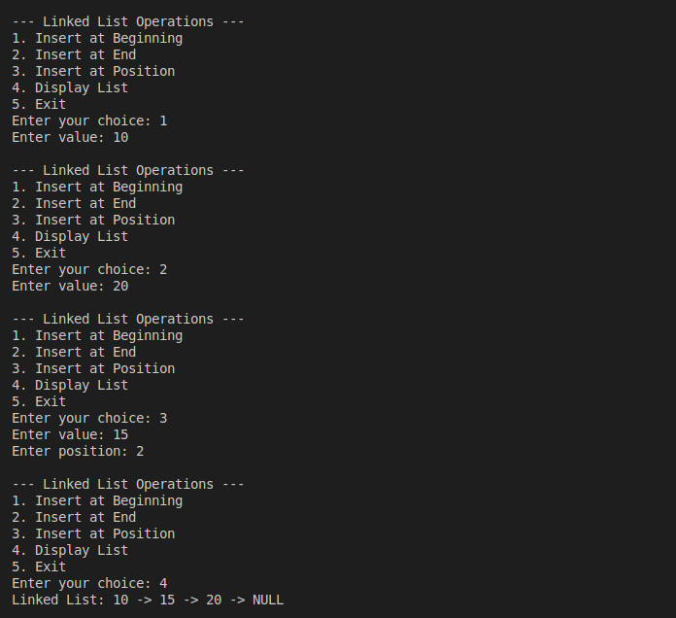

Problem 2 – Searching & Deletion in Linked List
Task:
1. Implement a function searchElement(int value) to find the position of a value in the list.
2. Implement a function deletePos(int pos) to delete a node at a given position.
3. Test both functions with your linked list.
Test Case:
• Current List: 5 -> 10 -> 15 -> 20 -> NULL
• Search for 15 → Output: Element 15 found at position 3
• Delete node at position 2 → Resulting List: 5 -> 15 -> 20 -> NULL

Code:

#include <iostream>
using namespace std;

struct Node {
int data;
Node* next;
};

class LinkedList {
private:
Node* head;
Node* tail;

public:
LinkedList() {
head = NULL;
tail = NULL;
}

Node* createNode(int value) {
Node* temp = new Node;
temp->data = value;
temp->next = NULL;
return temp;
}

void insertLast(int value) {
Node* temp = createNode(value);
if (head == NULL) {
head = tail = temp;
} else {
tail->next = temp;
tail = temp;
}
}

void searchElement(int value) {
Node* current = head;
int pos = 1;
while (current != NULL) {
if (current->data == value) {
cout << "Element " << value << " found at position " << pos << endl;
return;
}
current = current->next;
pos++;
}
cout << "Element " << value << " not found\n";
}

void deletePos(int pos) {
if (head == NULL) {
cout << "List is empty\n";
return;
}
if (pos < 1) {
cout << "Invalid position\n";
return;
}
if (pos == 1) {
Node* temp = head;
head = head->next;
if (head == NULL) tail = NULL;
delete temp;
cout << "Deleted node at position 1\n";
return;
}
Node* current = head;
for (int i = 1; i < pos - 1; i++) {
if (current == NULL) {
cout << "Position out of range\n";
return;
}
current = current->next;
}
if (current == NULL || current->next == NULL) {
cout << "Position out of range\n";
return;
}
Node* temp = current->next;
current->next = temp->next;
if (current->next == NULL) {
tail = current;
}
delete temp;
cout << "Deleted node at position " << pos << endl;
}

void display() {
if (head == NULL) {
cout << "List is empty\n";
return;
}
Node* current = head;
cout << "Linked List: ";
while (current != NULL) {
cout << current->data << " -> ";
current = current->next;
}
cout << "NULL\n";
}
};

int main() {
LinkedList list;
int choice, value, pos;
do {
cout << "\n--- Linked List Operations ---\n";
cout << "1. Insert at End\n";
cout << "2. Search Element\n";
cout << "3. Delete at Position\n";
cout << "4. Display List\n";
cout << "5. Exit\n";
cout << "Enter your choice: ";
cin >> choice;
switch (choice) {
case 1:
cout << "Enter value: "; cin >> value;
list.insertLast(value);
break;
case 2:
cout << "Enter element to search: "; cin >> value;
list.searchElement(value);
break;
case 3:
cout << "Enter position to delete: "; cin >> pos;
list.deletePos(pos);
break;
case 4:
list.display();
break;
case 5:
cout << "Exiting...\n";
break;
default:
cout << "Invalid choice!\n";
}
} while (choice != 5);
return 0;
}

